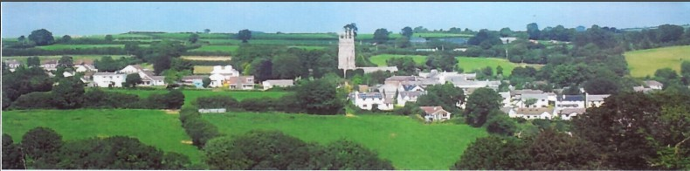
28th January 2024

Dear Councillor,

You are summoned to attend a meeting of North Hill Parish Council on Monday 5th February 2024 at 7.30pm in the Village Hall.
Please find attached the agenda for our meeting. We ask that if any member of the public has issues, they would like to raise that they contact the clerk prior to the meeting so that we can best manage them.
Please remember that the time allotted for Matters of Community Concern is not a forum to discuss what has taken place during this meeting and that any matter raised here would likely be added to the NEXT meeting agenda for discussion.

Yours faithfully,
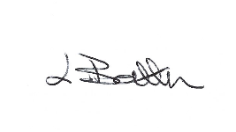
Lena Batten, Clerk to the Council
Members of the public are welcome to attend the meeting. However, we would like those attending to register prior to the meeting by emailing the Parish Clerk. Email clerk@northhillparish.org.uk

AGENDA
- TO RECEIVE APOLOGIES:
- CODE OF CONDUCT : a) TO RECEIVE DECLARATIONS b) TO GRANT DISPENSATIONS:
3. PUBLIC COMMENTS ON ITEMS ON THE AGENDA ONLY:
4. TO RECEIVE AND APPROVE THE MINUTES OF THE 4th January 2024 FULL COUNCIL MEETING:
5. ANY MATTERS ARISING FROM PAST MINUTES NOT ON THE CURRENT AGENDA:
6. TO CONSIDER PLANNING APPLICATIONS RECEIVED FROM CORNWALL COUNCIL BY DATE OF THIS MEETING:
6.1 PA23/09194 Lane End, North Hill – renewal of permission for the siting of a mobile home without complying with condition 1 of decision 94/1949 dated 14th November 1994 – Matter to proceed to committee.
7. TO REVIEW CORRESPONDENCE AND TO AGREED RESPONSES REQUIRED:
7.1 Cornwall Association of Local Councils Spring 2024 training programme.
7.2 To consider/resolve two further grant applications also previous application from St Torney’s church.
7.3 To resolve next steps following information received from Highways and Coads Green School both
agreeing to a notice board being fitted. 7.4 To discuss / resolve the option of a small monthly article in Cornwall and Devon Post at a quoted
£260.00 plus VAT or the option of a monthly parish magazine being re introduced.
7.5 To note for information fly tipping has been reported to Cornwall Council ref no: 101006849638.
7.6 To receive information from Tamar to Moor regarding services at Household waste recycling centre.
7.7 To receive information regarding switching off street lighting between midnight and 5am.
7.8 To receive information regarding the potential purchase of Lapel Pin Badges for D-Day celebrations.
7.9 To consider / resolve the request for public electric vehicle charges to be installed in the car park.
7.10 To consider / resolve the completion of the clerk’s probationary period.
7.11 To agree to advertise tender for the cutting of footpaths / graveyard for new contract from 1st April
2024 (copy enclosed).
8. APPROVAL OF THE LIST OF PAYMENTS / RECEIPTS FOR JANUARY 2024 & TO RECEIVE DECEMBER 2023 BANK STATEMENT:
8.1 AUTHORISATION OF EXPENSES INCLUDING SALARY:
i) £18.00 (PAYE G. Pollard Jan)
ii) £9.00 (bank Charges)
iii) £43.64 (room rent, phone, Lena Batten, Jan)
iv) £713.96 (Salary inclusive of tax, Lena Batten, Jan)
v) £24.00 (ICCM membership to 31st March 2024)
vi) £102.00 (ICCM Sexton training)
vii) £2.75 (recorded postage of Elan City cheque)
viii) £14.58 (ink, Lena Batten).
8.2 RECEIPTS: None.
8.3 To receive January 2024 bank statement:
Bank Statement as of 28th January 2024 - £18,749.78
9. TO REVIEW MONTHLY BUDGET RECONCILIATIONS:
9.1 Budget Sheet Attached.
10. TO REVIEW MONTHLY RAG: (Red, Amber, Green)
10.1 RAG Sheet attached.
11. To discuss general maintenance / upkeep of North Hill Parish footpaths. The clerk has reported path 528/15/1 in Bathpool as advised and requested a replacement stile for path 528/18/1.
12. REPORT FROM CORNWALL COUNCIL WARD MEMBER COUNCILLOR PARSONS:
13. TO REVIEW DETAILS FOR NORTH HILL PARISH COUNCIL CEMETERY: Sexton training for the clerk has been altered to Thursday 21st March 2024 due to overbooking. Membership will be paid until the 31st Marh 2024. No other updates.
14. ITEMS FOR INCLUSION AT THE NEXT MEETING:
15. DATE & TIME OF NEXT MEETING:
16. CLOSE OF BUSINESS:

